  Organisers  Österreichisch-Französisches  Zentrum für Annäherung in Europa |   Französisches Institut für  internationale Beziehungen

With the Friendly Support of vonvonvon
 |  |    | 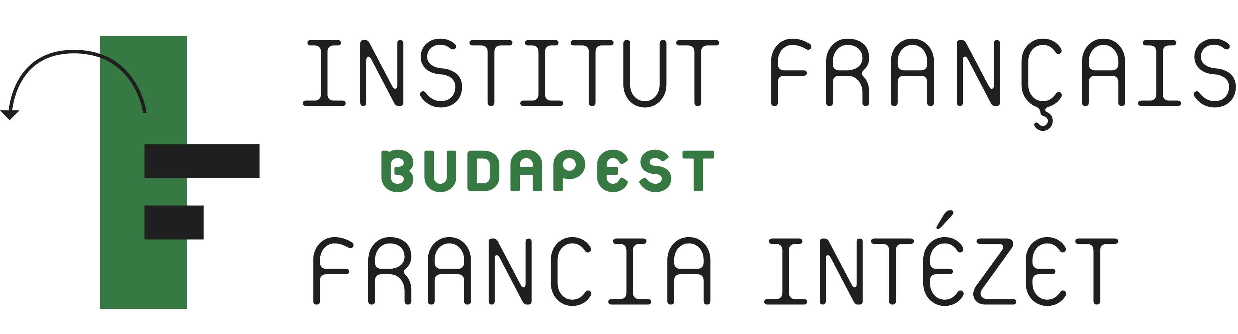 | 

APPLICATION FORM

for the International Conference
Hungary and Europe
Budapest, 4th of April 2011
Venue: Andrássy University
Pollack Mihály tér 3, 1088 Budapest

Name: …………………………………………………………………………………………...
Function: ……………………………………………………………………………………….
Institution: ……………………………………………………………………………………...
E-Mail: …………………………………………………………………………………………..

There is no participation fee!

Conference participation on Monday Morning, 4th of April 2011:


Conference participation on Monday Afternoon, 4th of April 2011:

Please note that we can only consider your application, if we receive it at least on Wednesday,
30 of April 2011. You will get a confirmation.
After that date your application may be refused due to capacity utilisation!!!

Please return this Application Form to Mrs. Petra Schuh-Leitner: petra.schuh@oefz.at or via Fax: +431/533.89.27.10

